KASAA

HELP CLEAN OUR CITY

AN INITIATIVE BY TEAM MANGO

Tushar K Naik

Suhas V

Vamanan T S

RNS INSTITUTE OF TECHNOLOGY

Purpose

In recent times, Bangalore has seen a drastic rise in problems related to garbage management and their proper disposal. Local pile-ups and heaps of garbage everywhere are a major concern. Bangalore generates 3,000 tons of waste every day, from households and commercial establishments. Around 70% of this waste is organic. The balance is accounted for, by inorganic and hazardous wastes.

* Unnecessary transportation of waste to the city outskirts only to cause pollution by **open burning**.
* Local composting of organic waste is restricted to a handful of private initiatives.
* Practically no attempts are being made to introduce waste segregation at source.
* Since there is **no waste segregation** taking place at source, retrieval of recyclable material is very difficult.
* Burning of waste takes place routinely all over the city even in crowded residential areas.
* Bad methods practiced in households, for instance, a lack of routine to **segregate waste**.
* Locals lack a sense of **belonging, awareness and urgency** to work towards solving such hazardous problems.
* BBMP officials are **unaware** of garbage piles that lie in residential areas due to a **lack of proper communication**.

Comprehending all these problems that surround us, it becomes our duty to protect our city by changing our daily practices and working together towards a greener future. Keeping this problem in mind, our team has decided to develop an Android Application that aims at eradicating problems related to Waste Management and Garbage disposal in our city and creating awareness on the same. Our aim is to contribute towards the restoration of Bangalore’s original name - The Garden City and help retain its inherent beauty.

Main Sections

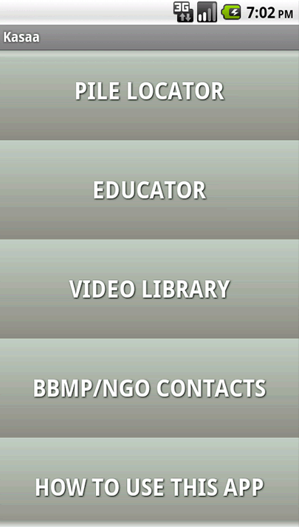

1: PILE LOCATOR

2: EDUCATOR

3: VIDEO LIBRARY

4: BBMP/NGO CONTACTS

5: HOW TO USE THIS APP

Pile Locator

* The most important section of the app is the ‘Pile Locator’
* The main intension behind this section is to help the local administrative body, the Bruhat Bengaluru Mahanagara Palike (BBMP), at identifying garbage pile-ups in the city.
* 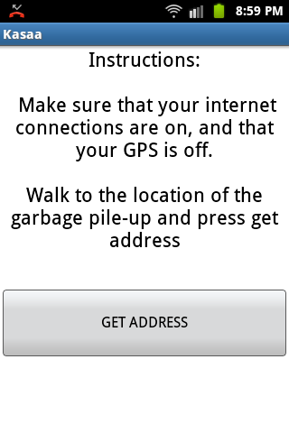If the user locates any kind of garbage pile-up, he needs to walk towards it, and press the GET ADDRESS button.
* If the internet connections are working fine, the specific address will be retrieved.
* An options of sending the address as a text message to the BBMP office will be available

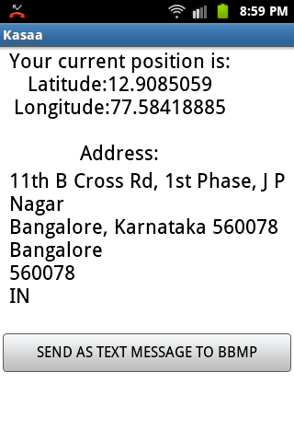

* On clicking the button, user will be redirected to the native messenger application
* The message will contain the address contents, as well as the recipients number (BBMP)
* The red circle currently shows a different number. This number will be changed to the BBMP number once collaboration is set up with BBMP.

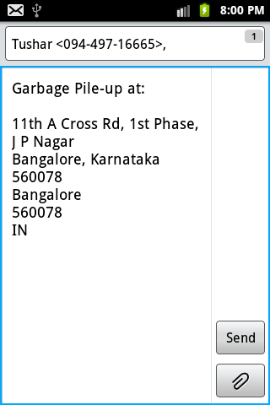Implementation

* Using the Location Managers requires certain permissions to be included in the manifest xml file
* Criteria may be set appropriately
* The updateWithNewLocation() function is called later
* Concept of reverse geocoding is used
* Local functions may be called to retrieve the latitude and longitude values
* Using a Geocoder, these values may be passed to generate specific addresses
* A StringBuilder is used to store the address dynamically
* Later, the string may be redirected using intents or the SMS Manager

Educator

* Considering the present situation, it becomes very important to educate everyone about waste segregation.
* This is a section that educates the user about Waste Management and Waste Segregation.
* Awareness is always the first step towards change.

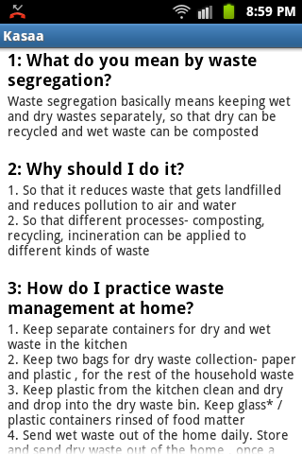Video Library

* This section allows the user to browse through a small library of links to videos
* 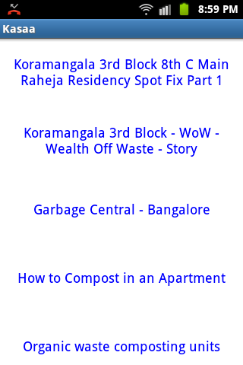Videos about local heroes who have made the difference and have stood out in trying to change their surroundings.
* Stories about people who have worked hard in order to bring about a change in the society, worked towards a greener and garbage free city.
* Links when touched, will redirect the user to his installed YouTube application, or his web browser

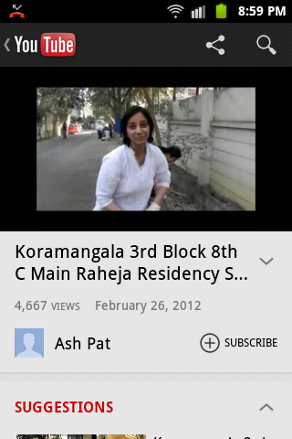BBMP/NGO CONTACTS

* Users are generally unaware about NGO’s that are dedicated to saving our city
* Hence, this section is dedicated to providing contact information about local recycling units and NGO’s.
* 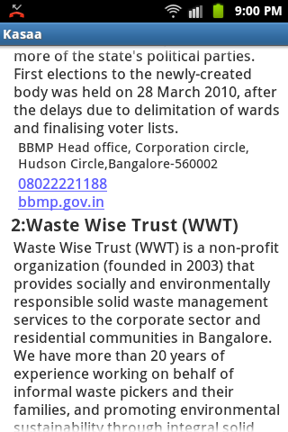A list of contacts containing the information of individuals or NGOs that tackle the issue of waste management on a daily basis. This will help the user maintain direct means of communication.

Results

* This Android Application will definitely bring about a change in the pattern that currently exists in the society. People using the app will understand the need for Waste Management and segregation. They will also learn simple ways of implementing them.
* Having understood the present situation, people will also be inspired at working towards bringing about a change.
* The BBMP will also be assisted greatly. The Pile Locator and the contact section will bridge the gap between the society and the government.
* Ultimately, with the people and the BBMP working together, our sole purpose of bringing back the original face of this Garden City, will be served.